Dalian Maritime Court Report on Trials (2020)

Special Statement: This paper is announced in Chinese and English, and the Chinese Version shall prevail.

TABLE OF CONTENTS

Foreword

I. Basic information

1. General situation

2. Case classification

3. Judicial openness

II. Work highlights
1. Focus on the big picture, and serve the construction of maritime hub with more strength
2. Go deep and solid, and build the law-based business environment with more commitments

3. Stimulate the vitality, enforce the laws and handle the cases with more efficiency

4. Promote the convenience, and build the one-stop diversified dispute resolution mechanism with more attention

5. People-oriented, and provide smart litigation service with more humanity

6. Toughen quality and ability, and build the team with more effectiveness

7. Clear and transparent, and implement judicial openness with more content

III. Problems and Suggestions
1. Suggestion for the domestic export enterprise

2. Suggestion for the insurance company
3. Suggestion for the ocean seamen
- Suggestion for the fishery boat accident investigation authority
IV. Typical Cases
- The period which has substantial impact on the contract performance is included into the duration of contract performance affected by the force majeure of COVID-19 pandemic
- Where the entity who declared imported goods to the Customs loses the identity of consignee, the related interested party is entitled to request the entity to cancel the declaration
- The multimodal transport operator, who does not issue the multimodal transport documents, takes the entire transport responsibility only to the shipper
- On condition that the claimant provides sufficient and effective guarantee, the maritime injunction should be granted and executed, not affected by the possessory lien on goods argued by the person against whom a claim is made
- The International freight forwarding company who does not accomplish the entrusted affairs has no right to require the principal to pay remuneration, if it fails to prove there are reasons not attributable to it
- When the contract-offering party is at fault for the invalidity of the construction subcontract which made his letter of guarantee invalid, he should assume joint and several liability for the corresponding payment in accordance with the law
- When the creditor and the debtor agree to change the principal contract of the ship operation loan, they shall have beforehand the written consent from the guarantor. Otherwise, the guarantor shall no longer bear the guarantee responsibility
- Consumers who purchase yachts are protected by the Law of the People’s Republic of China on the Protection of Consumers’ Rights and Interests, and producers shall bear punitive compensation liability for their frauds
- In the absence of evidence to the contrary, the maritime accident report made by the administrative organ can be used as evidence for the court to determine the facts of the case, but the responsibility of the parties should be determined by the court after examining the facts
- The evaluation of “land reclamation” should be based on both the actions and the objective results, rather than just the state of sea surface
- The Court upholds the ideal of enforcement with goodwill and politeness, combining enforcement measures with mediation means to provide high-quality judicial services for the development of enterprises
- Where the real estate is mortgaged before the lease, the auction of real estate made by the court with the mortgagee’s consent does not affect the realization of the mortgage right, even without the consent of lessee or secondary lessee
Concluding remarks

Foreword
With the continuous advancement of Maritime Power Strategy, Belt and Road Initiative, Pilot Free Trade Zone and Construction of International Maritime Judicial Center, the international credibility and influence of China’s foreign-related maritime adjudication has been increasingly enhanced, with a more positive and active attitude to integrate into the big picture, more quality and efficient judicial services to serve the national strategy and more pragmatic and fairer measures to safeguard the national strategy. Maritime courts need to grasp new requirements, assume new missions, and take practical actions to promote maritime justice to achieve new accomplishments. The giant ship of maritime adjudication will also follow the direction and channel guided by General Secretary Xi Jinping Thought on the Rule of Law, with the goal of letting the people feel fairness and justice in every judicial case, speed up the construction of international maritime judicial center, brave the wind and waves to open a new chapter, and set sail again with strong will and steady behavior.
In 2020, Dalian Maritime Court fully implemented Xi Jinping Thought on the Rule of Law, consciously practiced the new development concept, gave full play to the role of maritime adjudication, made every effort to create a market-oriented, law-based and international business environment, vigorously promoted reform and innovation, and accelerated the construction of “first-class maritime court”, and strove to promote various tasks to be in the forefront of Liaoning courts. The various tasks progressed steadily and continued to progress, providing powerful maritime judicial services and guarantees for the overall promotion of pandemic prevention and control and high-quality economic and social development.

I. Basic information
1. General situation
1.1 The numbers of accepted and closed cases were basically the same as last year. In 2020, the Court accepted 2,429 cases of various types, a decrease of 1.78% over last year. Among these cases, 2,339 cases were newly accepted, an increase of 0.43% over last year; 90 cases were left over from previous years, a decrease of 37.5% over last year; 2,367 cases were closed, a decrease of 0.67% over last year; the clearance rate reached 97.45%, an increase of 1.09 percent points over last year, ranking the first among the eleven maritime courts in China and the fourth among the intermediate courts in Liaoning Province.
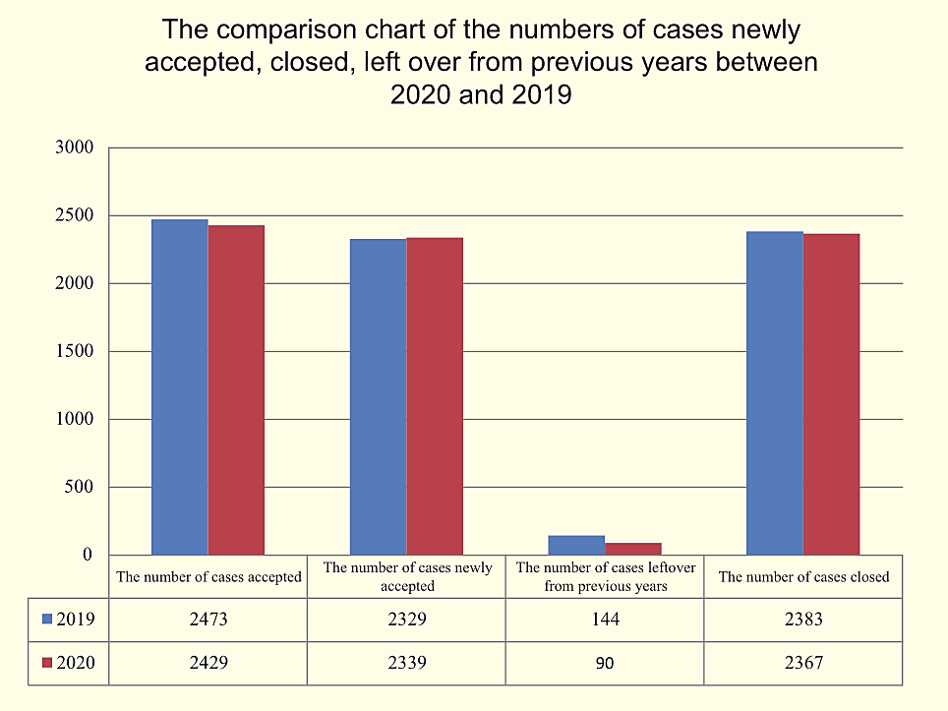
1.2 Major quality and effectiveness targets were well accomplished. The ratio of cases reversed or set aside for retrial by the second trial was 2.15%, a decrease of 1.32 percent points over last year, ranking the first among the intermediate courts in Liaoning Province; the conciliation ratio was 27.78%, an increase of 9.96 percent points over last year; the litigation withdrawal ratio was 23.29%, an increase of 5.53 percent points over last year; the question answering ratio after judgment was 100%, ranking the first among the intermediate courts in Liaoning Province; the ratio of satisfactory settlement without appeal was 84.79%, an increase of 6.93 percent points over last year; the application ratio of summary procedure was 65.92%, an increase of 18.55 percent points over last year; 125 open cases over 6 months were cleared up, and the clearance ratio reached 93.28%.
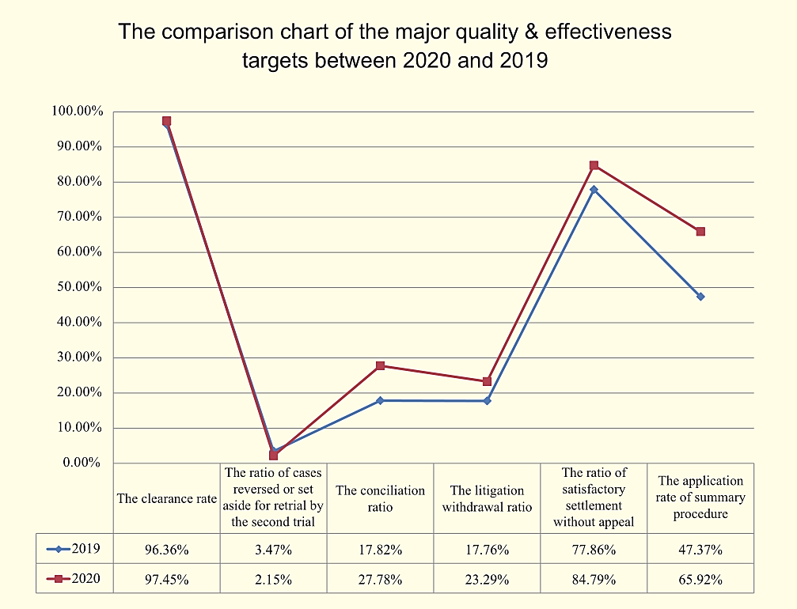
- Case classification
2.1 Civil cases data: 1,507 cases were accepted, an increase of 6.28% over last year. Among these cases, 1,451 cases were newly accepted, an increase of 8.2% over last year; 1,471 cases were closed, an increase of 8% over last year; the clearance rate reached 97.61%, an increase of 1.56 percent points over last year; the subject amount of the cases was RMB 2.966 billion, a decrease of RMB 3.805 billion over last year.
Among these civil cases, the Court accepted 1,339 admiralty and maritime cases, an increase of 2.45% over last year. Among the cases, 1,312 cases were newly accepted, an increase of 6.41% over last year; 1,305 cases were closed, an increase of 4.23% over last year; the clearance rate was 97.46%, an increase of 1.67 percent points over last year. Of the new contentious cases accepted, the number of the top 10 admiralty and maritime cases reached 1,113. The types of the above cases were as follows:
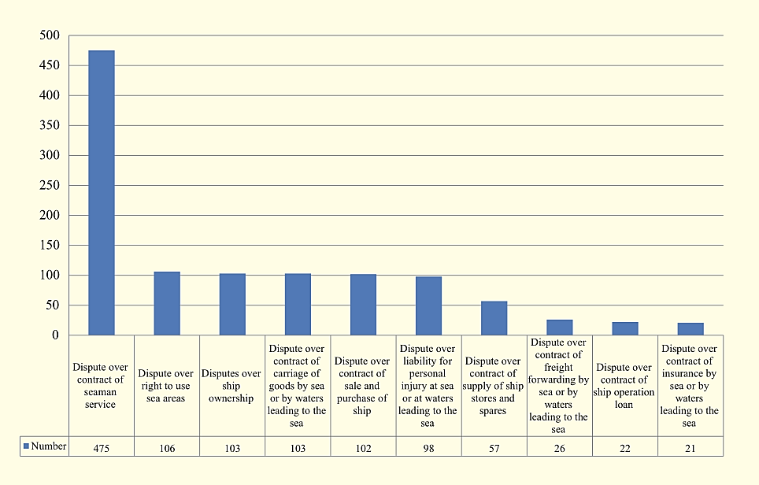
2.2 Administrative cases data: The Court accepted 96 maritime administrative cases, a decrease of 48.11% over last year. Among the cases, 83 cases were newly accepted, a decrease of 54.14% over last year; 93 cases were closed, a decrease of 46.55% over last year; the clearance rate was 96.88%, an increase of 2.83 percent points over last year; the subject amount of the cases was RMB 138 million, a decrease of RMB 285 million over last year.
2.3 Enforcement cases data: 752 cases were accepted, an increase of 0.8% over last year. Among the cases, 731 cases were newly accepted, an increase of 5.94% over last year; 730 cases were closed, an increase of 0.69% over last year; the arrival rate of enforcement subject was 66.06%, ranking the first among Liaoning provincial courts. The first three among the “four core targets” of “Basically Solving the Difficulties in Enforcement Work” achieved 100% and the fourth achieved 97.07% in clearance rate, far exceeding the criteria of three 90%s and one 80%. 12 cases involving the Party and government organs as special subjects were accepted, and 11 cases were actually closed, with an actual clearance rate of 91.67%; the total amount of application for enforcement was RMB 2.407 billion, with arrival of RMB 2.167 billion, and the arrival rate of enforcement was 90.03%, which successfully completed the target of “90% of the cases are actually executed and 90% of the money is in place” made by Liaoning High People’s Court.
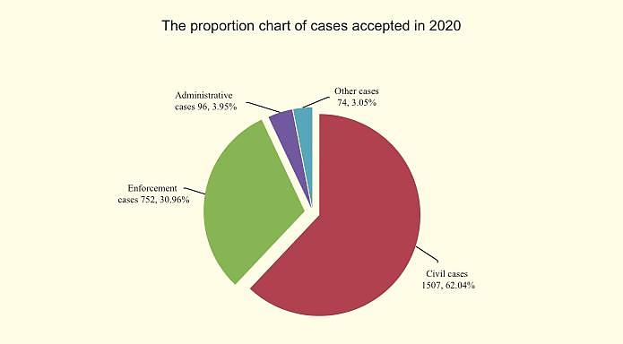
2.4 Dispatched tribunal cases data: Five dispatched tribunals accepted 1,010 cases of various types, an increase of 16.63% over last year. Among the cases, 975 cases were newly accepted, an increase of 18.76% over last year; 35 cases were left over from previous years, a decrease of 22.22% over last year; 992 cases were closed, an increase of 19.37% over last year; the clearance rate reached 98.22%, an increase of 2.22 percent points over last year. The ratio of cases reversed or set aside for retrial by the second trial was 1.78%, 0.37 percent point lower than the Court’s data; the conciliation ratio was 23.17%, 4.61 percent points lower than the Court’s data; the litigation withdrawal ratio was 30.74%, 7.45 percent point higher than the Court’s data.
Five dispatched tribunals accepted 849 admiralty and maritime cases, accounting for 63.41% of the total number of admiralty and maritime cases of the Court. Among the cases, 830 cases were newly accepted, accounting for 63.26% of the total admiralty and maritime cases of the Court; 832 cases were closed, accounting for 63.75% of the total admiralty and maritime cases of the Court; the subject amount of the cases was RMB 2.09 billion. The number of the top 5 admiralty and maritime cases reached 617. The types of the above cases were as follows:
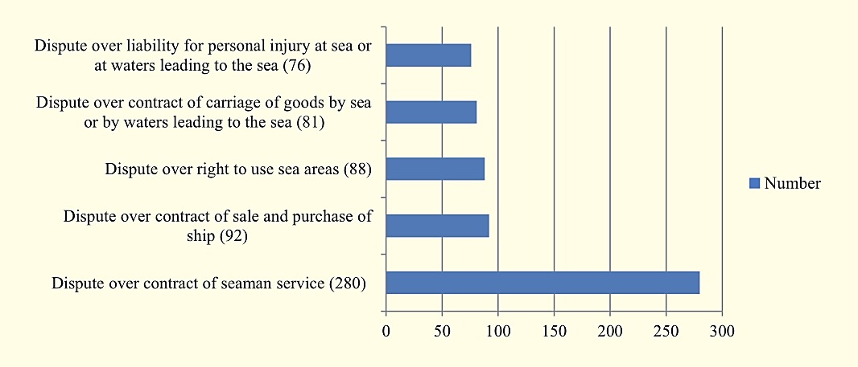
2.5 Arrest and auction of ships data: 50 ships were arrested, of which 4 involved foreign, Hong Kong, Macao and Taiwan affairs. 38 ships were auctioned, all of which were Chinese.
2.6 Cases involving foreign, Hong Kong, Macao and Taiwan affairs: The Court accepted 51 cases involving foreign affairs and 15 cases involving Hong Kong, Macao and Taiwan affairs, accounting for 2.72% of the Court’s total number; 47 cases involving foreign affairs and 13 cases involving Hong Kong, Macao and Taiwan affairs were closed. The cases involved nearly 20 countries and regions, including United Arab Emirates, Bermuda, Panama, Denmark, Germany, France, Gambia, South Korea, Marshall Islands, Japan, Switzerland, Spain, Greece, Singapore, North Korea, Congo (Brazzaville), Liberia, India，Hong Kong, and so on.
3. Judicial openness
1,011 trials were broadcast live on China Open Trials Online, with a total of 656,765 views. Live rate of trial was 66.97%, ranking the second among the intermediate courts in Liaoning Province. 3,305 judgment documents made in 2020 were issued on China Judgments Online, ranking the first among the intermediate courts in Liaoning Province. The Court disclosed the related judicial process information on China Judicial Process Information Online with an effective disclosure rate of 100%, ranking the first among the intermediate courts in Liaoning Province.

II. Work highlights
1. Focus on the big picture, and serve the construction of maritime hub with more strength
The Court fairly and efficiently adjudicated 51 cases involving foreign affairs, 15 cases involving Hong Kong, Macao and Taiwan affairs and equally protected the legal rights and interests of the litigants at home and abroad. The Court held the “Maritime Judicial Guarantee Forum for Urban Development” and provided the special research report named by Some Thoughts on the Construction of Dalian Maritime Hub for Dalian Municipal Party Committee, Dalian Municipal Government and Dalian Municipal People’s Congress. The Court issued the maritime trial report in Chinese and English versions and the judicial review report on maritime administrative cases, summarized and refined “Top Ten Typical Cases” “Top Ten Cases on Judicial Service for the People” and “Typical Cases involving the Belt and Road” to serve the new opening-up pattern.
2. Go deep and solid, and build the law-based business environment with more commitments
The Court issued the Work Plan for 4+9, visited more than 20 port & shipping enterprises, government organs, islands and fishing villages inside and outside Liaoning province, and convened 9 symposiums to solicit opinions and suggestions broadly. The Court thoroughly investigated 31 prominent problems concerning the law-based business environment, immediately rectified 27 thereof and constantly promoted 4 thereof with long-term mechanisms. The Court issued “Ten Commitments of Litigation Service”, winning a wide praise from the representatives of provincial and municipal people’s congress and news media. The Court introduced the experience of building the law-based business environment in Liaoning courts working conference. A case of confirming illegal administrative registration and compensation was selected in “Typical Cases on Strengthening the Construction of Law-based Business Environment in Liaoning Province”.
- Stimulate the vitality, enforce the laws and handle the cases with more efficiency
The Court reached a new record with the clearance rate 97.45%, ranking the first among the eleven maritime courts in China and the fourth among the 17 intermediate courts in Liaoning province. 125 open cases over 6 months were cleared up, and the clearance rate reached 93.28%. The Court realized new breakthrough in trial quality strategy, 3 cases were selected as Typical Cases of Maritime Trial in China and 3 as Typical Cases in Liaoning courts; In the selection activity of 5 “One Hundred Excellent Works” among Liaoning courts, 10 cases were selected into “One Hundred Excellent Cases”, 2 trials into “One Hundred Excellent Trials” and 2 judgments into “One Hundred Excellent Judgments”. In the “Annual Event of Improving Trial Quality, Efficiency and Public Credibility and Double Incentives Platform” of Liaoning courts, the comprehensive index of the Court ranked the first among the 17 intermediate courts. The Court perfected the long-term mechanism of solving the difficulties in enforcement, ranking the first concerning the quality and efficiency of enforcement among the three special courts in Liaoning province. The Enforcement Bureau was awarded “Collective Second Class Merit” by Liaoning High People’s Court in “Basically Solving the Difficulties in Enforcement Work”.
4. Promote the convenience, and build the one-stop diversified dispute resolution mechanism with more attention
The Court improved the one-stop diversified dispute resolution mechanism, and completed online inquiry and mediation by making full use of People’s Court Mediation Platform and China Maritime Trial System, and promoted all-round interconnection among diversified dispute resolution forces. The Court implemented the mode of “speedy trial judge handle cases at service counters” and “one-stop distribution, mediation, speedy trial and speedy hearing”, improved consecutively 74 “one-stop” quality and efficiency indicators, smoothed online and offline litigation service channels, implemented the commitments of handling cases immediate, one-off and online, endeavored to achieve “round-the-clock litigation services”, and pushed forward to realize “three prohibitions of influencing the impartiality of judicial trials through interested parties”.
5. People-oriented, and provide smart litigation service with more humanity
The Court dedicated to building a modern litigation service center, set up a vanguard post of Communist Party member, a president reception office for market entity, a judge reception room, a professional mediation room and a lawyer office. The “Legal Aid Workstation” was put into operation. The Court first released “Ten Commitments on Litigation Service” to the public to provide litigation risk assessment, self-filing, self-payment, cross-jurisdiction case filing, self-printing of documents and related litigation service, comprehensively improving the people’s judicial experience. The quality and efficiency evaluation of litigation service topped the ranking jointly among Liaoning courts. The Court was awarded the Advanced Unit of “Internet + Government Service”, and the litigation service center was awarded the provincial landmark litigation service center. The Court was awarded the Advanced Unit of Court Informatization Construction in China. The Court introduced the experience of smart court construction in the Liaoning court conference, and made a special report in the special informatization conference hosted by the Supreme Court, which was fully affirmed by Zhou Qiang, president of the Supreme Court.
6. Toughen quality and ability, and build the team with more effectiveness
The Court adheres to the revolutionary, standardized, specialized and professional direction, and strives for a loyal, clean and responsible judicial team. A group of young cadres were appointed to the middle and senior leading positions. The Court held six sessions of “Maritime Law Forum” integrated with politics learning, hotspots forecasting and practices exchanging. The Court set up 10 professional-judge-conference teams, a maritime trial report drafting team, a project researching team, a translation team and a cultural construction team. The Court made a comparative study on maritime justice among China, Japan and South Korea with great learning enthusiasm and research ability. A tribunal was awarded “The Advanced Collective of the National Courts”, a judge was awarded “Case Handling Model of the National Courts”, two cadres gained second-class merits, a judge was selected into “One Hundred Case Handling Experts” of Liaoning courts, a cadre was selected into “One Hundred Grassroots Pioneer” of Liaoning courts. In 2020, 42 research achievements won the awards, including 14 national-level items with an increase of 40% over last year and 28 provincial-level items with an increase of 3 times over last year. 3 research projects were completed, 1 of which was the key project of judicial research of Liaoning courts in 2020.
- Clear and transparent, and implement judicial openness with more content
The Court ranked highly among the intermediate courts in Liaoning Province in the effective disclosure rate of judicial process information, online live broadcasting rate of court trials and judgments online issuance rate. The Chinese and English website served as an impressive showcase for maritime justice. The WeChat official account updated daily, ranking the first among Chinese maritime courts on the total number of readings and likes. The Court held 4 press conferences, released 154 news articles on media and mainstream websites at provincial level or above, and filmed 10 promotional videos. The Court ranked the fifth in China Maritime Judicial Transparency Index Assessment issued by the Chinese Academy of Social Sciences, which was the best result in the Court’s history.

III. Problems and Suggestions
To fully exert the judicial function of maritime trial, foster a sound business environment, and provide a strong maritime judicial protection for the economic and social development, the Court summarizes the maritime trial practices and offers some suggestions for the following maritime entities on how to deal with the risks in operation, management or profession.
1. Suggestion for the domestic export enterprise
Forwarder’s Certificate of Receipt (FCR) is a receipt issued by a freight forwarder. It is not a document whereby the carrier warrants the delivery of the goods. It is commonly used in trade terms such as FCA and FOB. According to the FCR document, the foreign trade buyer is generally responsible for transport, ship chartering and space booking, while the domestic export enterprise, as the actual shipper, delivers the goods to the freight forwarder (usually designated by the foreign trade buyer) who issues the FCR to indicate receipt of the goods, then delivers the goods to the carrier and obtains a bill of lading or a sea waybill. Under the international trade contract, the domestic export enterprise negotiates payment with the bank on the presentation of the FCR, then the FCR passes through the bank to the foreign consignee, and the bill of lading or sea waybill passes to the agent of the freight forwarder at the foreign port of destination, who accepts the goods from the carrier on presentation of the bill of lading or sea waybill and then delivers the goods to the consignee. In accordance with Article 8 (1) of the Provisions of the Supreme People's Court on Several Issues Concerning the Trial of Cases of Disputes over Marine Freight Forwarding, the domestic export enterprise, as the actual shipper, may request the freight forwarder to deliver the bill of lading, sea waybill or other transport documents obtained from the carrier. If the domestic export enterprise does not make such a request, but directly accepts the FCR and uses it for settlement of foreign exchange, when it does not receive payment due to the risk of international trade and sue the freight forwarder for payment loss in a court, such a claim will not be upheld.
Suggestion: The domestic export enterprises should prudently evaluate the transaction risks in international trade, choose the trade term CIF or CFR as far as possible, and designate the freight forwarders to arrange transportation by themselves. Even after comprehensive consideration, the foreign trade buyer appoints the freight forwarder to arrange the transportation, and the domestic export enterprise shall also actively consult with the foreign trade buyer to adopt the bill of lading as the transportation and negotiation document. Meanwhile, the domestic export enterprise should fully comprehend the characteristics of the FCR, and realize that it does not have the function of delivering the goods guaranteed by the carrier. To avoid trade risks, under the provisions of Article 72 (1) of the Maritime Code of the People’s Republic of China and Article 8 (1) of the Provisions of the Supreme People's Court on Several Issues Concerning the Trial of Cases of Disputes over Marine Freight Forwarding, the domestic export enterprise should take appropriate measures to make known to the carrier a request for the issuance of a bill of lading or a request for delivery of a bill of lading to the freight forwarder, apply for a maritime injunction to a maritime court if such a request is frustrated, and actively exercise the right of claim for the issuance and delivery of the relevant documents.
2. Suggestion for the insurance company
In the disputes over marine insurance contracts tried by the Court, some insurance companies trigger exhausting litigations because of operating or managerial negligence, reducing their efficiency of claim settlement and increasing their operating cost. If the insurance agent entrusted by the insurance company, by its fault, fails to input the information of the insured which should have been entered into the list of the insured in the process of the insurance business, the insured (or his beneficiary) brings an action when the insurance company refuses to compensate after the insured incident. The court holds that the insurance company bears civil liability for negligence of the insurance agent. Since the crew members who work on the ship face multiple risks and the insured changes during the insurance period because of the mobility of crew members, such as the insured members increase, decrease and substitute from time to time, many ship operators tend to take out group personal accident insurance for a fixed number of crew members on their ships. In the event of the insured accident stipulated in the insurance contract, the insurance company dares not pay the insurance compensation until the court decides whether the crew member(s) involved in the insured accident is/are in the list of the insured. When the applicant applies river hull insurance for his inland river vessel, the insurance company does not record the scope of liability in the insurance policy, nor require the applicant to sign the policy or show the insurance clauses to the applicant. In the event of an accident involving an inland river vessel sailing beyond its approved inland river navigation area, a dispute arises between the applicant and the insurance company as to whether “coastal” falls within the scope of insurance liability. The court decides that the navigation beyond the approved area does not belong to the insurance liability of the insurance company and the insurance company shall not assume the insurance liability.
Suggestion: The insurance company should strengthen the supervision and management of the insurance agent, strictly examine the insurance agent’s qualification, effectively regulate the operation of the insurance agent, and prudently check the insurance policy, applicant’s eligibility information, the subject matter of the insurance and the insured amount filled out by the insurance agent to avoid the loss caused by his negligence. When accepting group personal accident insurance, the insurance company shall explicitly instruct the applicant that it may change the insured during the insurance period, and shall inform the applicant in detail and with an accuracy of the application process and time requirements for the change of the insured. When the applicant applies for a change of the insured, the insurance company shall timely examine such a request and modify the insurance contract and the list of the insured upon approval. When underwriting inland river hull insurance, the insurance company shall explicitly record the scope of liability agreed with the applicant in the application for insurance and the insurance policy, and shall precisely inform the applicant of the scope of insurance liability, to avoid exhausting litigations caused by the parties’ dispute over the scope of insurance liability.
- Suggestion for the ocean seamen
In judicial practice, when it is a foreign ship served by the seamen who engage in ocean operation, some seamen sign the labor contract with the dispatch entities in China, while others sign the contract of seaman service directly with the foreign shipowners. The former seamen establish the labor contract relationship with the dispatch entities, and the seamen’s rights and interests can often be fully and comprehensively protected in accordance with the Labor Contract Law of the People’s Republic of China. The latter seamen establish the service contract relationship with the foreign shipowners, which are not within the applicable scope of the above law, can be only confirmed in accordance with Article 41 in the Law of the People's Republic of China on the Application of Law in Foreign-related Civil Relations and clauses of application of law stipulated in the contract. In addition to the difficult delivery and enforcement, the seamen’s rights cannot be so comprehensively and fully protected as in accordance with the Labor Contract Law of the People's Republic of China. The confirmation and exercise of the maritime lien can be separated in accordance with Article 6 in the Provisions of the Supreme People’s Court on Several Issues concerning Trial of Cases Involving Seaman-related Disputes.The exercising period of the maritime lien is the scheduled period, and such a period will be terminated if the maritime lien has not been enforced within one year of the existence of such maritime lien.In judicial practice, the confirmations of the maritime lien requested by the seamen beyond one year of the existence of such maritime lien are not supported by the court.
Suggestion: The seamen engaging in ocean operation shall prefer to sign the labor contract and establish the labor contract relationship with the shipowner, ship operator or dispatch entity in China to comprehensively protect their rights and interests in accordance with the Labor Contract Law of the People's Republic of China. When the other party of the contract is behind in payment of wages, other remuneration, crew repatriation and social insurance costs attached by a maritime lien to the seamen, it is necessary for the seamen to confirm that they enjoy the maritime lien through litigation as soon as possible within one year of the existence of such maritime lien even though the ship attached with the maritime claim is not found. After the confirmation, the seamen shall also actively exercise the maritime lien within the above-mentioned one year to make their creditor’s rights fully guaranteed and avoid the extinguishment of the maritime lien because the one-year period expires.
- Suggestion for the fishery boat accident investigation authority
In recent years, the relevant administrative lawsuits have been often brought because the fishery boat accident investigation authority fails to perform duties according to law after the overwater work safety accident occurs to the fishery boat. The conflicts mainly focus on the failure of the fishery boat accident investigation authority in reporting the accident according to law, fully performing investigative functions with incomprehensive and incomplete investigation report content, or delivering the closing report of the accident to the parties concerned or delivering it timely.The failure of fishery boat accident investigation authority to perform duties legally goes against handling the follow-up civil disputes related to the accident and is harmful for the administrative organ to establish the good image of law-based governance.
Suggestion: The fishery boat accident investigation authority shall comprehensively master the working form of accident investigation which it has the right to conduct stipulated in the Provisions for Reporting, Investigating and Handling Overwater Safety Accidents of Fishery Boats and the content required in the accident investigation report, perform the investigation functions according to law, carry out the complete investigation on the content which shall be included in the accident investigation report, form a complete and detailed accident investigation report and timely deliver the accident closing report covering the accident investigation report content to the parties involved. As a result, the parties involved will be convinced of the results of the report, and it will further embody the administrative organ’s working attitude of being dedicated, serious and rigorous, honest and fair in handling the accident.

IV. Typical Cases
1. The period which has substantial impact on the contract performance is included into the duration of contract performance affected by the force majeure of COVID-19 pandemic
In the case of dispute over charter party between Tangshan Caofeidian Xiangkun Shipping Co., Ltd. (hereinafter referred to as Xiangkun Company) as the plaintiff and Dalian Shipbuilding Industry Co., Ltd. (hereinafter referred to as DSIC) as the defendant, DSIC chartered the floating crane ship owned by Xiangkun Company for the overwater hoising operation with the agreement that the operating period was from October 16, 2019 to January 24, 2020, the grace period was from January 25 to February 8, 2020 with no charge, and the demurrage shall be charged for extended use. Xiangkun Company completed the majority of hoising operation from October 16, 2019 to January 23, 2020. DSIC had no arrangement for hoising operation from January 24 to 30, 2020. Affected by the COVID-19 pandemic, Dalian COVID-19 pandemic prevention and control command issued the NO.3 order on January 31, 2020, which commanded all kinds of enterprises in the city shall resume work no earlier than 24:00 on February 9, 2020. Both the two companies resumed work on February 10, 2020. Through mutual consultation, Xiangkun Company completed the rest of hoising operation from February 11 to 24, 2020. Xiangkun Company argued that DSIC should be responsible for the demurrage from February 9 to 24, 2020. The Court held that, after the COVID-19 pandemic was identified as a public health emergency, the prevention and control measures taken by governments at all levels and relevant departments to protect people’s health and safety should constitute force majeure. The period from January 25 to 30, 2020 was the Spring Festival and also the legal holiday in China. DSIC did not arrange Xiangkun Company to carry out the hoising operation during the period, nor prove that DSIC made preparation work related to the hoising operation during the period. The period was the duration of force majeure affected by the COVID-19 pandemic but had no substantial impact on the contract performance, thus it should not be included into the duration of contract performance affected by the COVID-19 pandemic. The duration of contract performance affected by the COVID-19 pandemic was from January 31 to February 8, 2020. The Court ruled that DSIC paid Xiangkun Company RMB 1,133,600 of demurrage and its interest.
- Where the entity who declared imported goods to the Customs loses the identity of consignee, the related interested party is entitled to request the entity to cancel the declaration
In the case of dispute over removal of obstacles between Cocamar Cooperativa Agroindustrial (hereinafter referred to as Cocamar Company) as the plaintiff and Liaoning XinShi Trading Company (hereinafter referred to as XinShi Company) as the defendant, Cocamar Company as the shipper, consigned soybeans from Brazil, and Evergreen Company as the carrier, issued three original bills of lading, which noted the consignee was to order by XinShi Company. When the goods arrived at Dalian port, XinShi Company declared to China Customs against the copy of bill of lading as consignee. Later, Cocamar Company returned the above-mentioned full set of original bills of lading, Evergreen Company altered the consignee at the request of Cocamar Company and reissued the bills of lading. The legal holder of the second set of bills of lading was unable to declare and take delivery of the goods since Xinshi Company had made declaration. The Court held that, the soybean involved was imported goods, and customs declaration was the compulsory procedure for taking delivery of goods. XinShi Company was not the holder of the original bills of lading and had no right to take the delivery of above-mentioned goods. Evergreen Company and Cocamar Company had the right to negotiate and change the articles such as the consignee of the contract. The second set of bills of lading should be effective and valid in the case. XinShi Company was not the consignee anymore and its customs declaration hindered Cocamar Company from realizing the rights under bill of lading in accordance with the law. Therefore the Court ruled that XinShi Company cancelled the customs declaration.
- The multimodal transport operator, who does not issue the multimodal transport documents, takes the entire transport responsibility only to the shipper
In the case of dispute over contract of carriage of goods by sea between Cathay Century Products Insurance Co., Ltd. (hereinafter referred to as Cathay Company) as the plaintiff and Damu International Logistics Group Co., Ltd. and Liaoning Xindamu Logistics Co., Ltd. (hereinafter referred to as Xindamu Company) as the defendants, Xindamu Company entered a transport contract with Dalian Huarui Heavy Industry International Trade Co., Ltd. (hereinafter referred to as Huarui Company), the outsider of the case, agreeing that Xindamu Company was responsible for inland transportation of goods, export declaration and inspection to delivery of goods EX-ship’s hold at the port of destination from China factory to Shanyong port of Vietnam. Under a voyage charter, Xindamu Company transported the above goods by chartering MV YINGFU from Tairong International Shipping Company, the outsider of the case. The shipping agency issued the bill of lading on behalf of the captain. When MV YINGFU arrived at the port of destination, some of the goods were found damaged. The right of subrogation to claim for compensation was transferred to the cargo insurer, Cathay Company, after Cathay Company paid the indemnity to Taisu Hejing Company, the consignee noted in the bill of lading. The Court held that, Xindamu Company and Huarui Company established the legal relationship of multimodal transport contract in accordance with the Maritime Code of the People’s Republic of China. As multimodal transport operator, Xindamu Company, who did not issue the multimodal transport documents, took the entire transport responsibility only to its counterpart of the contract, Huarui Company. Cathay Company failed to prove that the bill of lading involved in the case was authorized by Xindamu Company or issued by the shipping agency on behalf of Xindamu Company, the contract of carriage goods by sea proved by the bill of lading was not established between Xindamu Company and Taisu Hejing Company. Therefore, the Court rejected the whole claim of Cathay Company.
4. On condition that the claimant provides sufficient and effective guarantee, the maritime injunction should be granted and executed, not affected by the possessory lien on goods argued by the person against whom a claim is made
In the case of compulsory delivery between Xiamen Jianfa Products CO., Ltd. (hereinafter referred to as Jianfa Company) as the Claimant and Maersk A/S (hereinafter referred to as Maersk Company) as the person against whom a claim is made, Maersk Company, in the hearing organized by the Court, argued that it did not release goods but exercised the possessory lien on goods in accordance of the law, which didn’t breach the terms of contract of carriage of goods by sea. The Court held that, the breach of legal provisions or contractual stipulations by the person against whom a claim is made should be one of conditions where the maritime injunction is granted. Maersk Company, the carrier under the contract of carriage of goods by sea, was obliged to deliver the goods to the consignee or the holder of bill of lading, and the failure to deliver the goods breached its duty. In addition, the purpose of exercising the possessory lien on goods is to guarantee the realization of creditor’s right. Maersk Company argued to exercise the possessory lien on goods, but Jianfa Company, as the consignee noted in the bill of lading, provided the sufficient and effective bank guarantee for releasing the goods, which not only guaranteed the realization of the carrier’s creditor’s right and interest, but also avoid the further expansion of goods loss and expenses. Therefore, the Court granted the maritime injunction in accordance with the law and ordered Maersk Company to release the goods to Jianfa Company.
5. The International freight forwarding company who does not accomplish the entrusted affairs has no right to require the principal to pay remuneration, if it fails to prove there are reasons not attributable to it
In the case of dispute over contract of freight forwarding by sea between Yantai Anxin International Logistics Co., Ltd. (hereinafter referred to as Anxin Company) as the plaintiff and Dalian Jincheng Logistics Supply Chain Co., Ltd. (hereinafter referred to as Jincheng Company) as the defendant, Anxin Company authorized Jincheng Company to handle the general affairs about five shipments from Dalian, China to Singapore, including export booking (BBK split hoisting), stacking, packing, strapping, reinforcement and inbound transportation. Jincheng Company accepted the authorization but was frustrated during the process of arranging the goods to enter the port. The goods failed to ship as scheduled, but Jincheng Company still required Anxin Company to pay remuneration. Anxin Company claimed the reason the goods failed to enter the port was that Jincheng Company did not hoist the special container involved in the case by BBK split hoisting. Jincheng Company argued that the failure was due to the weather. Both the parties failed to provide sufficient evidence to support their opinions. The Court held that, in accordance with Article 405 of the Contract Law of the People's Republic of China which provides that if the entrustment contract is dissolved or the entrusted affairs cannot be accomplished due to reasons not attributable to the agent, the principal shall pay corresponding remuneration to the agent, Jincheng Company, as the trustee, failed to prove that the failure to ship the goods was due to reasons not attributable to it, therefore there was no legal basis for it to accept Anxin Company’s remuneration and it should returned the remuneration.
6. When the contract-offering party is at fault for the invalidity of the construction subcontract which made his letter of guarantee invalid, he should assume joint and several liability for the corresponding payment in accordance with the law
In the case of dispute over port dredging contract between Ningbo Yongyi Ocean Engineering Co., Ltd.(hereinafter referred to as Yongyi Company) as the plaintiff and Dalian Hangsheng Port Construction Engineering Co., Ltd. (hereinafter referred to as Hangsheng Company) as the defendant and Dalian Huichang Terminal Co., Ltd. (hereinafter referred to as Huichang Company) as the defendant, Huichang Company offered the port berth construction project to Hangsheng Company without port construction qualification, and Hangsheng Company subcontracted the dredging project of the harbor basin to Yongyi Company without construction qualification. Both the above-mentioned contracts were invalid. Although the latter contract was cancelled before the completion of the project, yet Hangsheng Company recognized the quality of completed project. Therefore, the Court ruled that Hangsheng Company should make the corresponding payments to Yongyi Company. Since the contract between Hangsheng Company and Yongyi Company was invalid, the letter of guarantee issued by Huichang Company to Yongyi Company for the payment of the project was invalid, too. Knowing that Hangsheng Company did not have the relevant construction qualifications, Huichang Company still offered the port berth construction project to Hangsheng Company and confirmed that Hangsheng Company subcontracted the dredging project of the harbor basin to Yongyi Company, which belonged to the situation of providing a guarantee for the principal contract knowing that it is invalid, and Huichang Company is thereupon at fault for the invalidity of the guarantee contract. In accordance with the provisions of Article 8 of the Interpretation of the Supreme People's Court on Several Issues Concerning the Application of the Guarantee Law of the People’s Republic of China, the Court ordered Huichang Company to assume joint and several liability for one third of the aforementioned project prices.
7. When the creditor and the debtor agree to change the principal contract of the ship operation loan, they shall have beforehand the written consent from the guarantor. Otherwise, the guarantor shall no longer bear the guarantee responsibility
In the case of dispute over loan contract for ship operation between Bank of China Limited Dandong Branch (hereinafter referred to as Bank of China Dandong Branch) as the plaintiff and Dandong Jinshengshui Fishery Co., Ltd. (hereinafter referred to as Jinshengshui Company), Dandong Feng’ao Ship Industry Co., Ltd. (hereinafter referred to as Feng’ao Company), Song X and Zhang X as the defendants, as agreed, Feng’ao Company’s term of guarantee was up to the date when the ship was registered for mortgage. Since the lender Bank of China Dandong Branch and the borrower Jinshengshui Company failed to register the mortgage for the ship as agreed in the loan contract, the consequence of unreasonable extension of the guarantee term shall not be borne by Feng’ao Company. Moreover, Bank of China Dandong Branch did not pay the loan to Feng’ao Company, the borrower’s counterparty and the guarantor of the loan contract, as agreed in the loan contract, and changed the loan recipient who had been agreed in the contract. In accordance with Article 24 of the Guarantee Law of the People's Republic of China which provides “When the creditor and the debtor change the principal contract, they shall have beforehand the written approval from the guarantor. The guarantor assumes no more guarantee responsibilities if the change is made without its approval”, the Court rejected Bank of China Dandong Branch’s request for Feng’ao Company to bear joint and several responsibility.
- Consumers who purchase yachts are protected by the Law of the People’s Republic of China on the Protection of Consumers’ Rights and Interests, and producers shall bear punitive compensation liability for their frauds
In the case of dispute over contract of sale and purchase of ship between Yu X as the plaintiff and Dalian Cihang Yacht Co., Ltd. (hereinafter referred to as Cihang Company) as the defendant and Wehai JinyunYacht Co., Ltd. (hereinafter referred to as Jinyun Company) as the defendant, Yu X ordered a new yacht from the seller, Cihang Company. As agreed, Cihang Company was responsible for handling the ship inspection procedures of the yacht. Later, Cihang Company delivered a yacht and ship inspection certificates of the same model built by the manufacturer Jinyun Company. In the process of negotiating and handling the case of a bottom break of the yacht, Yu X discovered that there were discrepancies in the ship inspection procedures on where the yacht left the factory and where it was naturalized. Yu X believed that Cihang Company and Jinyun Company had sales fraud, and requested to rescind the yacht sales contract, and requested Cihang Company and Jinyun Company to jointly refund RMB 180,000 of the purchase price and jointly compensate for the loss of RMB 360,000. The Court held that, Cihang Company delivered an unqualified yacht as the subject of the sales contract, and failed to prove that he had ordered a new yacht from Jinyun Company, paid the price, transported the new yacht to Dalian or done the related things. It was presumed that Cihang Company intentionally concealed the true status of the yacht when he entered into the contract, which constituted a fraud. The design and purpose of this yacht were for private use, which was within the scope of commodities specified in Article 2 of the Law of the People's Republic of China on the Protection of Consumers’ Rights and Interests. According to the Law, the Court ruled to rescind the yacht sales contract signed between Yu X and Cihang Company, ordered Cihang Company to refund the purchase price of the yacht to Yu X and bear punitive compensation liability, and rejected Yu X’s claim against Jinyun Company.
- In the absence of evidence to the contrary, the maritime accident report made by the administrative organ can be used as evidence for the court to determine the facts of the case, but the responsibility of the parties should be determined by the court after examining the facts
In the case of dispute over liability for personal injury at sea between Li X, Wei X, Liu X as the plaintiffs and Xu X as the defendant, Xu X hired Sang X to drive the motorboats at Dalian Changxing Island Beach and charged tourists to experience the motorboat sailing at sea. In the sea ride process, the motorboat driven by Sang X cut Liu XX with an injury in the head who was swimming in the sea, and Liu XX died despite emergency rescue efforts. In accordance with the employer’s liability provided in Paragraph 1 of Article 9 of the Interpretation of the Supreme People's Court on Several Issues concerning the Application of Law in the Trial of Personal Injury Compensation Cases, Sang X was responsible for the accident, and Xu X as an employer bore the tort liability. In addition, Article 26 of the Tort Liability Law of the People's Republic of China provides that, “Where the infringee is also attributable to the damage, the liability of the infringer may be mitigated.” Although the maritime accident report made by the administrative organ held that Liu XX was not obviously at fault as a tourist, the Court held that in the case of several motorboats sailing on the sea, Liu XX should know the danger of swimming and take necessary protection and warning measures. Liu XX didn’t take necessary warning measures，and was at fault for the accident, too. The Court ruled that Xu X’s liability as the infringer was reduced by 10%.
- The evaluation of “land reclamation” should be based on both the actions and the objective results, rather than just the state of sea surface
In the case of revocation for administrative penalty decision between Zou X as the plaintiff and Dalian Jinpu New District Agriculture and Rural Bureau as the defendant, Zou X claimed that the part of sea use in 2015 was just to level out the historically formed waste accumulation area, and the survey report also showed that the accumulation area had been formed in 2014, so the sea use should not be considered as land reclamation. Dalian Jinpu New District Agriculture and Rural Bureau argued that according to the coastline revision data published in 2009, the accumulation area belonged to the sea area and had been formed into the land, so Zou X’s use of the sea should be identified as land reclamation. The Court held that, according to the relevant provisions of sea area management, “land reclamation” was referred as the land that can become an effective shoreline after building disks and modifying sea areas, completely changing the natural properties of the sea area. The criterion of land reclamation should be the act of building embankments and reclaiming the sea for land, resulting in the formation of a new stable boundary between land and sea. Zou X did not build the embankment to enclose the sea area, and the new stable sea-land boundary was formed before the use of the sea, Zou X’s leveling and construction in the accumulation area should not be considered as land reclamation. Therefore, the Court revoked the administrative penalty decision of Dalian Jinpu New District Agriculture and Rural Bureau.
- The Court upholds the ideal of enforcement with goodwill and politeness, combining enforcement measures with mediation means to provide high-quality judicial services for the development of enterprises
In the case of application for dispute over recourse of guarantee contract between China Orient Asset Management Co., Ltd. Liaoning Branch (hereinafter referred to as Orient Asset Liaoning Company) as the applicant and China Zhonghaizhi Co., Ltd. (hereinafter referred to as Zhonghaizhi Company) as the person subjected to execution, which was to enforce designated by Liaoning High People’s Court. Since the end of 1999, Zhonghaizhi Company owed Orient Asset Liaoning Company US $2,288,514.57 and its interest. After placing the case on the docket, the Court immediately and fully inquired and controlled the bank accounts of Zhonghaizhi Company and froze more than RMB 700 thousand. According to the property clues provided by Orient Asset Liaoning Company, the Court found that Zhonghaizhi Company, as the major shareholder, held the stocks of the listed company, and the case could be closed by selling the stocks directly, but Zhonghaizhi Company requested the suspension of enforcement. In order to avoid incalculable negative impact on the business development of the enterprise, the Court did not rigidly take sell-off measures, but actively organized both the two parties to calculate and negotiate repeatedly on the principal and interest of the creditor's rights. Finally, the two parties reached a settlement. Zhonghaizhi Company actively fulfilled the outstanding principal and interest with the total number of about RMB 47 million. After the case was closed, the listed company’s additional stock placement was on schedule and not adversely affected.
12. Where the real estate is mortgaged before the lease, the auction of real estate made by the court with the mortgagee’s consent does not affect the realization of the mortgage right, even without the consent of lessee or secondary lessee
In the case of lawsuit of enforcement opposition between Hu X as the plaintiff and Wang X, Wang XX, Zheng X as the defendants, Shenyang Metal Materials General Factory, Zhou X, Shenyang Jiadian Logistics Co., Ltd., Qu X as the third parties, Hu X as the secondary lessee raised an opposition for enforcement on the grounds that the Court’s auction was illegal without his consent and removal of the lease in advance, and claimed that he had a legal and valid lease on the real estate and refused to perform the enforcement duty of vacating the house requested by the Court. The Court held that the real estate had been mortgaged before the lease, and the auction of real estate with the mortgagee’s consent was a specific way for the mortgagee to exercise the right of mortgage to realize the repayment of the debt. The proceeds of the auction had priority in paying off the mortgagee’s claim, and the lease right did not adversely affected the realization of the prior mortgage, and should not accord with the articles about the lease right provided in the Provisions of the Supreme People Court on Auction and Sale of Properties in Civil Enforcement Proceeding by People's Courts, “continuous existence in the to-be-auctioned property may affect the realization of the prior real right for security and other priorities of getting repaid, the people's court may eliminate them prior to the auction”, so the auction did not need to obtain the consent of the secondary lessee and remove the right of lease in advance. The Court held that the auction was justified and rejected Hu X’s claim.

Concluding remarks
With the rapid development of marine economy, managing the oceans has become an integral part of national governance system. Over 30-year development and practice of maritime courts has fully demonstrated that maritime courts are specialized courts for not only adjudicating maritime and admiralty cases, but also providing a solid judicial guarantee to enhance the implementation of national strategies and promote the construction of a maritime community with a shared future during the historical intersection of the “two centuries”. Working hard to write the opening answer sheet and striving to create the future of maritime court, Dalian Maritime Court will always insist that the justice should respond to what the people need. From the perspective of serving the big picture, the Court will clarify the responsibilities, assume the missions and make the implementations. The Court will make a good start and escort it well with the power of maritime justice. The Court will protect people’s livelihood, relieve people’s worries and warm people’s hearts with cozy and smart services. The Court will enhance the responsibility, activate the vitality and promote the first-class building with a strong style. The Court will strive to press the accelerating key of the first-class maritime court’s construction, and endeavor to paint a magnificent picture scroll of first-class construction.

(The above information provided by Dalian Maritime Court）

Including maritime cases and maritime special procedure cases, excluding non-litigation preservation review cases, state compensation cases, judicial aid cases, judicial assistance cases and enforcement cases.
Including civil cases, non-litigation preservation review cases, and administrative cases.
Article 8 (1) of the Provisions of the Supreme People's Court on Several Issues Concerning the Trial of Cases of Disputes over Marine Freight Forwarding provides, “if a freight forwarding enterprise books space upon the entrustment of the contracting shipper and also delivers goods to the carrier upon the entrustment of the actual shipper, when the actual shipper requests the freight forwarding enterprise to deliver the bill of lading, seaway bill or any other shipping document obtained by the freight forwarding enterprise, a people's court shall uphold such a request.”
For example, the dispute over marine freight forwarding contract between the plaintiff, Shenyang Jianing Plastic Mechanical Automatic Ltd. and the defendant, Tianjin Fanyi International Freight Forwarder Services Ltd. Dalian branch, and the case number was (2019) L72MC No. 980.
Article 72 (1) of the Maritime Code of the People’s Republic of China provides, “When the goods have been taken over by the carrier or have been loaded on board, the carrier shall, on demand of the shipper, issue to the shipper a bill of lading.”
Article 2 (1) of the Provisions on the Supervision and Administration of Insurance Agents (Order No. 11 [2020] of the China Banking and Insurance Regulatory Commission) provides, “For the purpose of these Provisions, "insurance agents" means institutions or individuals that collect commissions from insurance companies and handle insurance business on behalf of insurance companies within the scope authorized by insurance companies, including full-time insurance agencies, sideline insurance agencies, and individual insurance agents.”
For example, the dispute over marine insurance contract between the plaintiffs, Zhou X etc. and the defendant, Huatai Insurance Co., Ltd., Jingzhou Center Affiliate and the third party, Cong X, and the case number was (2019) L72MC No. 982.
For example, the dispute over marine insurance contract between the plaintiffs, Chen X etc. and the defendant, Pingan Endowment Insurance Co., Ltd. Liaoning Branch, and the case number was (2018) L72MC No. 268.
For example, the dispute over marine insurance contract between the plaintiff, Zheng X and the defendant, PICC Property and Casualty Co. Ltd., Huaibin Affiliate and the third party, Henan Huaibin Rural and Commercial Bank Co. Ltd., and the case number was (2019) L72MC No. 22.
Article 162 of the Civil Code of the People's Republic of China provides, “A civil juristic act performed by an agent in the principal’s name within the scope of authority is binding on the principal.”
Article 20 of the Insurance Law of the People's Republic of China provides, “The insurance applicant and insurer in an insurance contract may modify the contract upon consultation. To modify an insurance contract, the insurer shall endorse the insurance policy or any other insurance certificate or attach an approval slip thereto, or the insurance applicant and insurer shall enter into a written agreement on the modification.”
Article 2 of the Labor Contract Law of the People's Republic of China provides, “The Law applies to the conclusion, performance, change, cancellation or termination of the labor contract between the organizations (such as enterprises, individual economic organizations and private non-enterprise units) in the People's Republic of China (hereinafter referred to as Employer) and the worker.”
Article 41 of the Law of the People's Republic of China on the Application of Law in Foreign-related Civil Relations provides, “The parties involved can choose the laws to which the contract is applicable upon the agreement. If not, the law in the habitual residence of the party whose performance of obligation reflects the characteristics of the contract the most or other law with the closest connection to the contract shall prevail.”
In case that there is no such provision, the parties involved can assert the application of law pursuant to the provisions of Article 17 (2) of the Provisions of the Supreme People's Court on Several Issues concerning Trial of Cases Involving Seaman-related Disputes, “As for the labor contract between the seaman and the shipowner, if the party involved doesn't choose the applicable law, but claim the law applicable to the place of labor dispatched, main office of the shipowner or flag country, such claim shall be supported.”
For example, the dispute over contract of seaman service between the plaintiff, Shi X and the defendant, Jiade Sea Transportation Co., Ltd., etc., and the case number was (2020)L72MC No. 601.
Article 6 of the Provisions of the Supreme People's Court on Several Issues concerning Trial of Cases Involving Seaman-related Disputes provides, “As for the maritime claim attached by a maritime lien, if the seaman fails to request the arrest of the ship giving rise to the maritime lien pursuant to Article 28 of the Maritime Law of the People's Republic of China, but claim the confirmation that it has the right of priority against the ship giving the maritime lien within a certain period, such claim shall be supported.” The period specified in the preceding paragraph shall be one year of the existence of such maritime lien.
For example, the dispute over contract of seaman service between the plaintiff, Zhang X and the defendant, Joint Pacific Shipping Co. Ltd., and the case number was (2020) L72MC No. 1189.
Article 29 (1) of the Maritime Code of the People's Republic of China provides, “A maritime lien shall, except as provided for in Article 26 of this code, be extinguished under one of the following circumstances: (I) The maritime claim attached by a maritime lien has not been enforced within one year of the existence of such maritime lien; ......”
For example, the dispute over confirmation of maritime lien between the plaintiff, Liu X and the defendant, Shi X, and the case number was (2020) L72MC No. 1043.
Article 22 (1) of the Maritime Code of the People's Republic of China provides, “The following maritime claims shall be entitled to maritime liens: (I) Payment claims for wages, other remuneration, crew repatriation and social insurance costs made by the Master, crew members and other members of the complement in accordance with the relevant labor laws, administrative rules and regulations or labor contracts; .....”
For example, the dispute over failure to perform statutory duties between the plaintiff, Nie X and the defendant, Yingkou Agriculture and Rural Comprehensive Development Service Center, and the case number was (2019) L72XC No. 36.
Article 5 (1) of the Provisions for Reporting, Investigating and Handling Overwater Safety Accidents of Fishery Boats (Decree [2012] No. 9 of Ministry of Agriculture) provides, “The departments of fishery administration under the people’s governments at or above the county level and their subordinate fishery administration and port supervision agencies (hereinafter referred to as fishery boat accident investigation authorities) are responsible for reporting the overwater safety accidents of fishery boats.”
Article 22 of the Provisions for Reporting, Investigating and Handling Overwater Safety Accidents of Fishery Boats (Decree [2012] No. 9 of Ministry of Agriculture): “The overwater safety accident investigation report shall include the following contents: (I) Overview and main performance data of boat and facilities; (II) Name, address and contact way of the owner or operator of boat and facilities; (III) Accident occurrence time, place, process, weather, water area and loss etc.; (IV) Cause, type and nature of the accident; (V) Salvation and rehabilitation treatment; (VI) Affirmation of accident responsibilities; (VII) Rectification measures required to be taken by the parties involved; (VIII) Handling opinions or suggestions.”
Article 21 of the Provisions for Reporting, Investigating and Handling Overwater Safety Accidents of Fishery Boats (Decree [2012] No. 9 of Ministry of Agriculture) provides, “The fishery boat accident investigation authority shall complete the overwater safety accident investigation report within 60 days as of the date when the accident report is received. In particular cases, the period of completing the accident investigation report can be prolonged after getting the approval from the superior fishery boat accident investigation authority, but the prolonged period shall not exceed 60 days. The time required for inspection or appraisal isn't included into the accident investigation period.”
The case number was (2020) L72MC No. 403.
The case number of the first instance was (2019) L72MC No. 947, and the case number of the second instance was (2020) LMZ No. 257.
The case number of the first instance was (2017) L72MC No. 885, and the case number of the second instance was (2020) LMZ No. 269.
The case number was (2020) L72XB No. 2.
The case number of the first instance was (2020) L72MC No. 542, and the case number of the second instance was (2020) LMZ No.1244.
The case number of first instance was (2018) L72MC No. 7, and the case number of the second instance was (2020) LMZ No.338.
The case number was (2020) L72MC No. 182.
The case number of the first instance was (2020) L72MC No. 64, and the case number of the second instance was (2020) LMZ No.1190.
The case number was (2020) L72MC No. 334.
The case number was (2019)L72XC No. 8.
The case number was (2020) L72Z No. 275.
The case number was (2020) L72MC No. 527.

